(Approx. 332 words)

TypeItIn - a Review
By Leah Clark, Editor, Los Angeles Computer Society
January 2016 issue, User Friendly
www.lacspc.org
leahjc (at) sbcglobal.net

When, at the Daytime SIG, someone asked about software to create macros, I mentioned that I have been using TypeItIn from wayget.com for years. It lets you create buttons that will type any information you want in any application. It is a time-saver for typing in frequently used information like names, addresses, e-mail addresses, etc. It also prevents me from making typos!

Assign usernames, passwords, applications, websites, and other items to a single button. Groups that contain sensitive information may be password-protected. You can launch applications or websites with a click of a button.

You can define up to 50 single key buttons. The program can automatically type in the time, date, month, or day of the week as well.

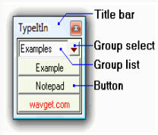
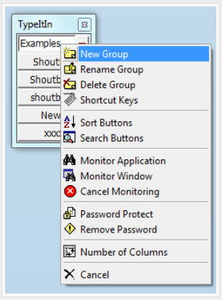
When you download TypeItIn a box like this will appear on your des top. By right clicking on the group name, you can rename the group anything you want, and perform other functions as noted on the drop-down menu.

When you right click on a button you can edit the button, insert a new button or delete a button, and more.

When you click on “New Button” you can enter a name for the button and the text you want that button to type for you. In this example, the button is Name, and “Jane Doe” is the Text to be typed; then you click on Record Typing and on Save & Close. In a document or form, place your cursor where you want “Jane Doe” to be typed and click on the button. It will appear in that spot.
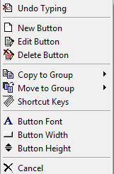

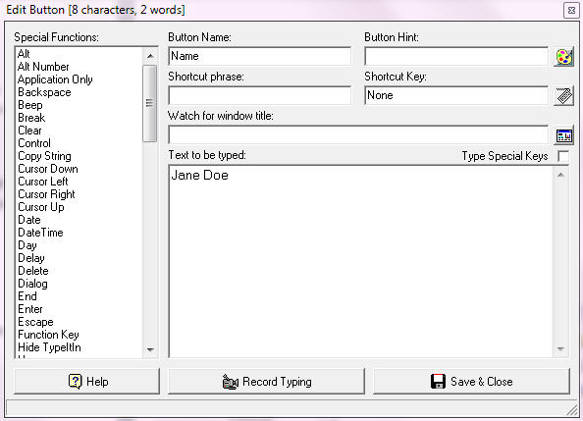
There are a lot of other functions in this program, as you can see from the menu. Check out YouTube tutorials.

At http://wavget.com you can download a 30-day free trial. The Professional version is $19.95 per user. More advanced versions cost more; I don’t think they are needed by most users.

